Council on Agricultural Innovation - Scientific, Ethical, Legal, Social Issues (CAI-SELSI)

Nathanael Johnson

Storytelling and evidence: Brokering peace between natural enemies

April 28th 2017, 11 AM
Seminar
233A HUB (Hetzel Union Bldg)

RSVP for Pizza Lunch Following

Please RSVP to: CAI.SELSI@gmail.com subject line Nathanael Johnson HUB, number attending in the body

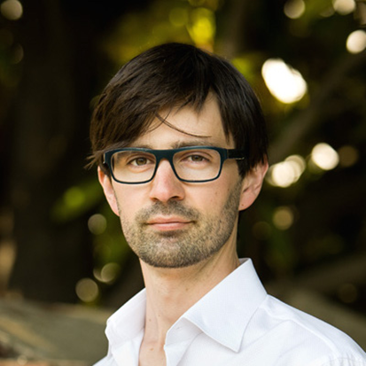
The truth of the story is fundamentally true only to that story - and the truth of a scientific finding is fundamentally true only to the conditions under which data were gathered. The two don’t play well together. It’s rare that there’s a story that perfectly represents the truth of a scientific or economic finding, because every person has her own confounding factors. But there’s also no more powerful tool for communicating ideas than story, and if used in combination with honesty and humility, it can be employed honorably. I’ll use examples from my work to show how to use the foundational elements of story, detail, moment-by-moment progression, characters, and unlikely examples of success to pique curiosity and burst confirmation bias.

Nathanael Johnson is a journalist who lives in Berkeley, California with his wife and two daughters. He is the food writer for Grist (https://grist.org/author/nathanael-johnson/), and has taught at the University of California, Berkeley, Graduate School of Journalism. He was an editor at Meatpaper. He’s written two books: All Natural and Unseen City. He grew up in Nevada City, California. (http://www.nathanaeljohnson.org/about/)

The Council on Agricultural Innovation: Scientific, Ethical, Legal, Social Issues (CAI-SELSI) is excited to share upcoming events and opportunities to engage in talks and seminars pertaining agricultural issues. To keep up with our latest work and future events, please like us on Facebook by searching “Penn State Council on Agricultural Innovation” and follow us on Twitter @PSUAgChat or visit our website, http://agsci.psu.edu/research/snip/biotechnology. Contact Mark Guiltinan, mjg9@psu.edu, for more information on CAI-SELSI.

