Council on Agricultural Innovation – Scientific, Ethical, Legal, Social Issues (CAI-SELSI)

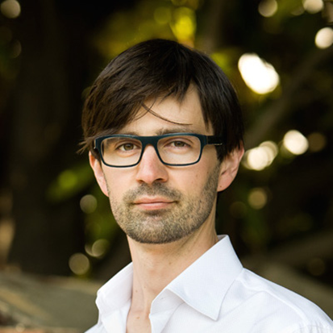
Nathanael Johnson

Thursday, April 27, 2017 – 7 PM
Berg Auditorium
100 Life Sciences Bldg

Light Refreshments at 6:30pm – RSVP required

What if we put poverty first?

Please RSVP to: CAI.SELSI@gmail.com subject line Nathanael Johnson BERG, number attending in the body

For the past three years that I’ve been writing at Grist, it’s been my job to try and figure out the answers to one big problem: How do we, as a species, feed ourselves without causing global collapse? Food moves to money and away from poverty, so I soon discovered the question I was really asking was: How do we tackle poverty without wrecking the planet? The answers still have a lot to do with agriculture, because 70 percent of the 700 million people living in extreme poverty across the globe are farmers, and no country has reduced poverty on a large scale without a corresponding investment in agriculture. There’s a fundamental tension between these two goals because growth, the escalator out of poverty runs on fossil fuels and forests.

There are no perfect solutions. There’s always some tradeoff between alleviating poverty and protecting the environment. But there are good solutions: If we are smart, we can set our priorities to trade a little carbon for a lot of prosperity. My reporting on this issue has led me to the hypothesis that people who care about the environment and social justice should embrace change, growth, and innovation. We simply don’t have the technology, infrastructure, and basic housing to meet the needs of the global population. Traditionally the environmental movement has focused on stopping things - conservation and preservation aim to prevent change. But poor people need change. In this talk I’ll outline the historical evidence that suggests that growth - spurred by investments in small farms - can lead to mass reduction in poverty and environmental improvements.

Nathanael Johnson is a journalist who lives in Berkeley, California with his wife and two daughters. He is the food writer for Grist (https://grist.org/author/nathanael-johnson/), and has taught at the University of California, Berkeley, Graduate School of Journalism. He was an editor at Meatpaper. He’s written two books: All Natural and Unseen City. He grew up in Nevada City, California. (http://www.nathanaeljohnson.org/about/)

The Council on Agricultural Innovation: Scientific, Ethical, Legal, Social Issues (CAI-SELSI) is excited to share upcoming events and opportunities to engage in talks and seminars pertaining agricultural issues. To keep up with our latest work and future events, please like us on Facebook by searching “Penn State Council on Agricultural Innovation” and follow us on Twitter @PSUAgChat or visit our website, http://agsci.psu.edu/research/snip/biotechnology. Contact Mark Guiltinan, mjg9@psu.edu, for more information on CAI-SELSI.

